External Linking

# Program 1:

<html>

<head>

    <title>work1</title>

</head>

<body>

    <center>

        <h1>MEDIA COMPANY</h1>

        <br>

        <h2>

        <a href="LinkElements/work2.html">ABOUT</a>

        <a href="LinkElements/work3.html">CONTACT</a>

        <a href="LinkElements/work4.html">SERVICE</a>

        <a href="LinkElements/work5.html">GALLERY</a>

        </h2>

        <img src="https://encrypted-tbn0.gstatic.com/images?q=tbn:ANd9GcTPKti7yQxkSivFWBUQbRaSIKcvIwQkYZoWnA&s" height="450">

    </center>

</body>

</html>

Linking Pages 1 :

<html>

<head>

    <title>about</title>

</head>

<body>

    <center>

        <h1>MEDIA COMPANY</h1><br>

        <img src="https://encrypted-tbn0.gstatic.com/images?q=tbn:ANd9GcT5IZpcUMwa9bCk8UMo9khsTIHFA62xDtXuBw&s" alt="">

        <h3>E-MAIL:media@gmail.com</h3>

    </center><br>

    <h2>ABOUT</h2><hr>

    <p>

        A company description is an overview or summary of a business. It's an important part of a business plan that often briefly describes an organization's history, location, mission statement, management personnel and, when appropriate, legal structure.

        A company description is an overview or summary of a business. It's an important part of a business plan that often briefly describes an organization's history, location, mission statement, management personnel and, when appropriate, legal structure.

        A company description is an overview or summary of a business. It's an important part of a business plan that often briefly describes an organization's history, location, mission statement, management personnel and, when appropriate, legal structure.

        A company description is an overview or summary of a business. It's an important part of a business plan that often briefly describes an organization's history, location, mission statement, management personnel and, when appropriate, legal structure.

    </p>

</body>

</html>

Linking Pages 2 :

<html>

<head>

    <title>CONTACT</title>

</head>

<body><br><br>

    <center>

        <h1>CONTACT</h1>

        <img src="https://encrypted-tbn0.gstatic.com/images?q=tbn:ANd9GcTT5ph2krZ-6hQiiljINDFOGxn3ObgxwHrkfg&s" alt="">

    <h2>

        Banglore, Second Street-M109, India <br>

        768905432

    </h2>

    <h3>E-MAIL:media@gmail.com</h3>

    </center>

</body>

</html>

Link pages 3:

<html>

<head>

    <title>SERVICE</title>

</head>

<body>

    <h1>SERVICE</h1>

    <img src="https://www.livecareer.com/lcapp/uploads/2020/09/ways-you-could-make-a-contribution-to-our-company.jpg" height="300" alt="">

    <ul type="disc">

        <li>PHOTOGRAPHY</li>

        <li>VIDEOGRAPHY</li>

        <li>SHOOTINGS</li>

        <li>POSTERS</li>

        <li>DESIGNS</li>

        <li>CUSTOMISATION</li>

        <li>ALBUMN</li>

    </ul>

</body>

</html>

Link Page 4 :

<html>

<head>

    <title>gallery</title>

</head>

<body>

    <center>

        <h1>GALLERY</h1>

        <table height="550" width="800">

            <tr>

                <td><img src="https://encrypted-tbn0.gstatic.com/images?q=tbn:ANd9GcT0HZZONB2Xa0AoNJhtiqwQHnRIxFaHUteyaQ&s" height="250" width="250"></td>

                <td><img src="https://encrypted-tbn0.gstatic.com/images?q=tbn:ANd9GcS1Dw7-4lVfRq74_YEiPEt4e-bQ0_6UA2y73Q&s" height="250" width="250"></td>

                <td><img src="https://encrypted-tbn0.gstatic.com/images?q=tbn:ANd9GcSxlT_-PpQJbt3DsWOZDQYohRy4YF8ck1n8PA&s" height="250" width="250"></td>

            </tr>

            <tr>

                <td><img src="https://encrypted-tbn0.gstatic.com/images?q=tbn:ANd9GcRwRTd1Il3wmvLJEC4nW14UJ1R_j5_2SkHA_Q&s" height="250" width="250"></td>

                <td><img src="https://encrypted-tbn0.gstatic.com/images?q=tbn:ANd9GcS8Zx-dv1PyoEbM_9rCmSKk04ugXfEfOyJoMQ&s" height="250" width="250"></td>

                <td><img src="https://encrypted-tbn0.gstatic.com/images?q=tbn:ANd9GcTJ5rWVM145b5C4xvQOsMiz8tIJHEMrzCGbHQ&s" height="250" width="250"></td>

            </tr>

        </table>

    </center>

</body>

</html>

# OutPuts :

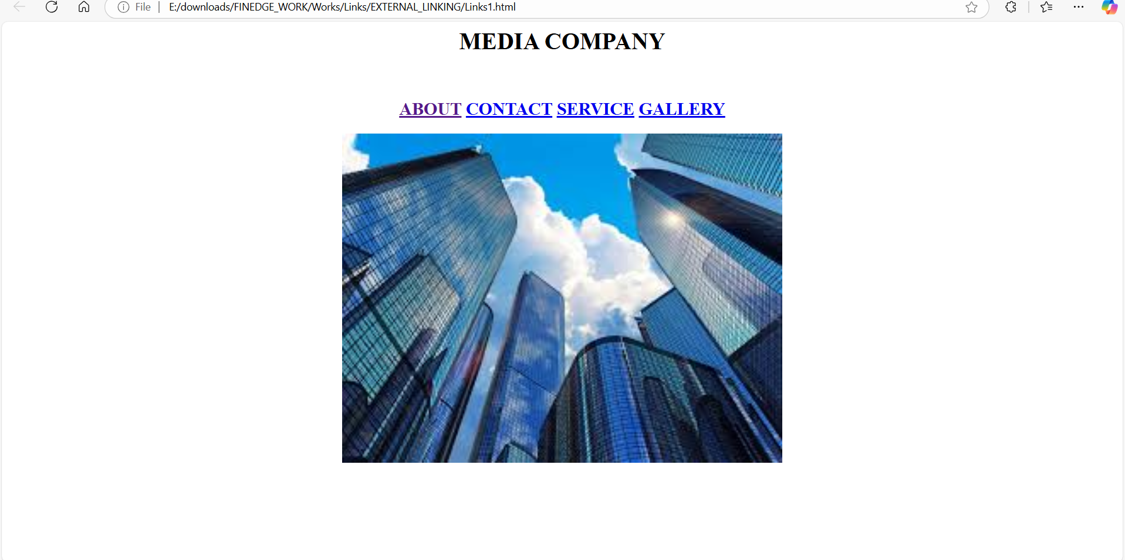

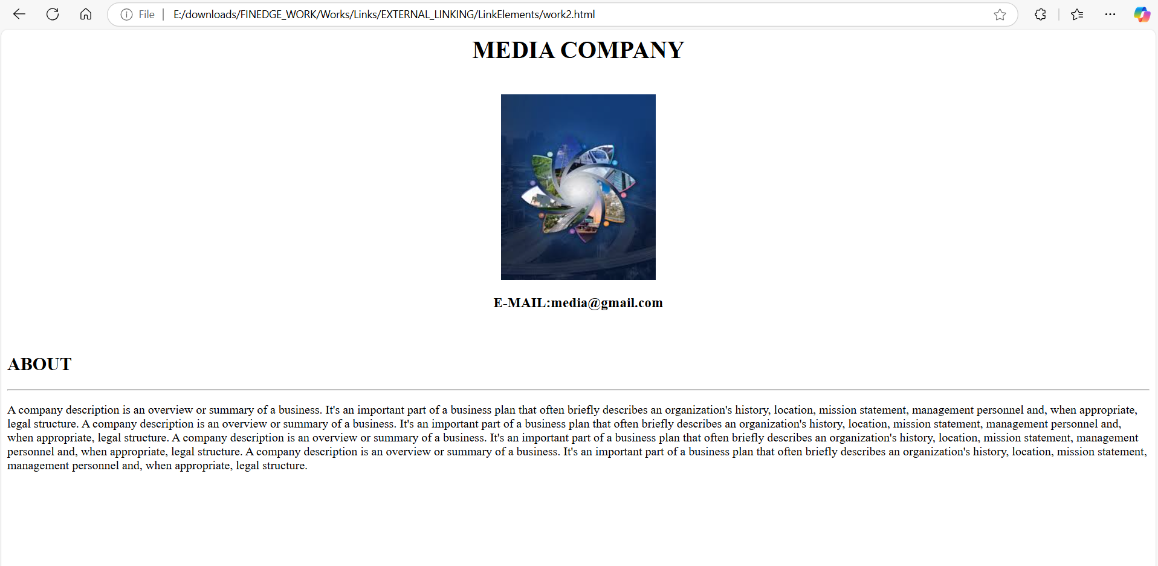

# Program 2 :

<html>

<head>

    <title>work6</title>

</head>

<body>

    <center>

    <h2>

        <a href="LinkElements/work7.html">ANU</a>

        <a href="LinkElements/work8.html">RAHUL</a>

        <a href="LinkElements/work9.html">ARUN</a>

        <a href="LinkElements/work10.html">SOURAV</a>

    </h2>

    </center>

</body>

</html>

Link Pages 1 :

<html>

<head>

    <title>anu</title>

</head>

<body>

    <center><img src="https://encrypted-tbn0.gstatic.com/images?q=tbn:ANd9GcRwRTd1Il3wmvLJEC4nW14UJ1R_j5_2SkHA_Q&s"></center>

    <center>ANU</center>

    <center>POST:CEO</center>

    <center>SALARY:65000</center>

    <center>INCENTIVE:5000</center>

</body>

</html>

Link Pages 2 :

<html>

<head>

    <title>RAHUL</title>

</head>

<body>

    <center><img src="https://encrypted-tbn0.gstatic.com/images?q=tbn:ANd9GcS8Zx-dv1PyoEbM_9rCmSKk04ugXfEfOyJoMQ&s"></center>

    <center>RAHUL</center>

    <center>POST:TYPEWRITER</center>

    <center>SALARY:15000</center>

    <center>INCENTIVE:5000</center>

</body>

</html>

Link Pages 3 :

<html>

<head>

    <title>arun</title>

</head>

<body>

    <center><img src="https://encrypted-tbn0.gstatic.com/images?q=tbn:ANd9GcTJ5rWVM145b5C4xvQOsMiz8tIJHEMrzCGbHQ&s"></center>

    <center>ARUN</center>

    <center>POST:MANAGER</center>

    <center>SALARY:45000</center>

    <center>INCENTIVE:5000</center>

</body>

</html>

Link Pages 4 :

<html>

<head>

    <title>SOURAV</title>

</head>

<body>

    <center><img src="https://encrypted-tbn0.gstatic.com/images?q=tbn:ANd9GcSxlT_-PpQJbt3DsWOZDQYohRy4YF8ck1n8PA&s"></center>

    <center>SOURAV</center>

    <center>POST:ASS.MANAGER</center>

    <center>SALARY:45000</center>

    <center>INCENTIVE:5000</center>

</body>

</html>

# OutPuts :

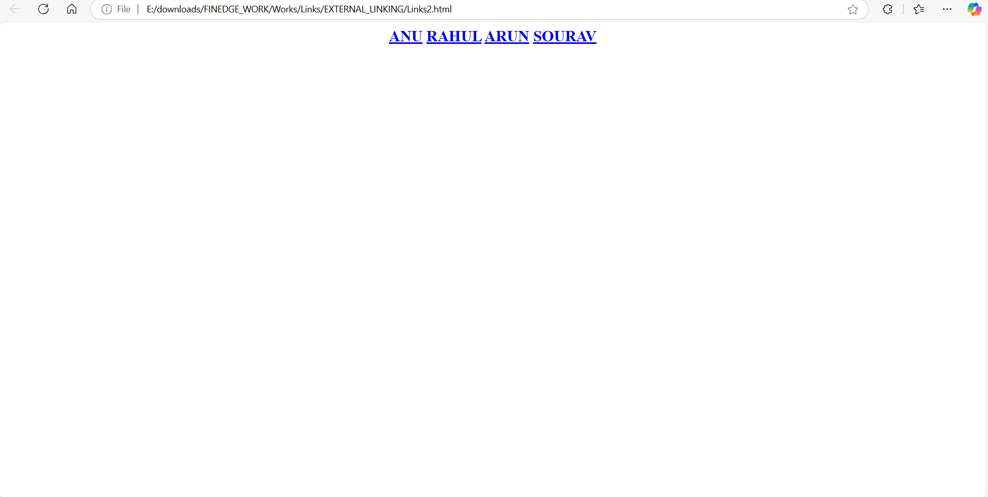

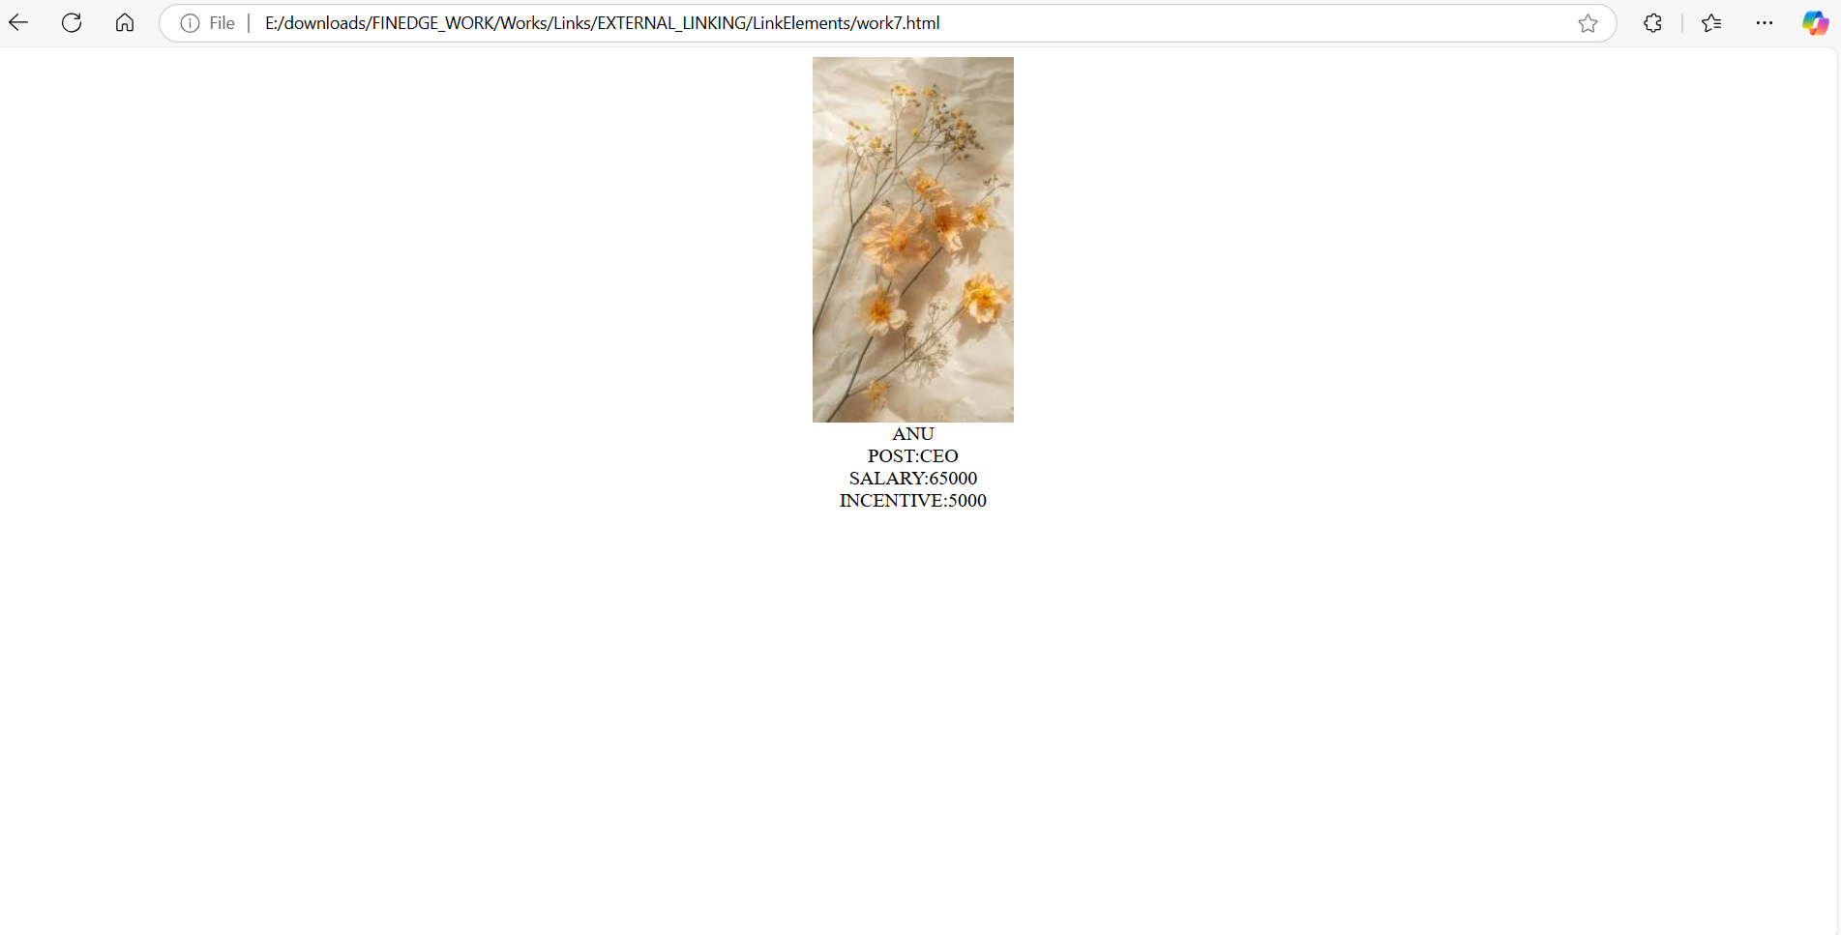

# Program 3 :

<html>

<head>

    <title>work11</title>

</head>

<body>

    <center>

    <a href="LinkElements/work12.html"><img src="https://encrypted-tbn0.gstatic.com/images?q=tbn:ANd9GcQseavgzsh5VpuB739_ZUydRoJWshWbhhVyFQ&s" height="350" width="350"></a>

    <a href="LinkElements/work13.html"><img src="https://encrypted-tbn0.gstatic.com/images?q=tbn:ANd9GcRLXP2yEnEbzSY6RAyCgNe2DmaHNGUaJ4SrZw&s" height="350" width="350"></a>

    <a href="LinkElements/work14.html"><img src="https://encrypted-tbn0.gstatic.com/images?q=tbn:ANd9GcQ0xuNB8_9GAwNQ8ocPnLnz6KqhnQSTh0Lnpg&s" height="350" width="350"></a>

    <a href="LinkElements/work15.html"><img src="https://www.thespruce.com/thmb/a4VspYOj2z7uhCiHYyUwjVAovFA=/1500x0/filters:no_upscale():max_bytes(150000):strip_icc()/GettyImages-154954628-2bd4e1df58fa406aaa524aa5bf180908.jpg" height="350" width="350"></a>

    <a href="LinkElements/work16.html"><img src="https://www.hitchcockandking.co.uk/wp-content/uploads/2016/10/Mexitegel.jpg" height="350" width="350"></a>

    <a href="LinkElements/work17.html"><img src="http://t1.gstatic.com/images?q=tbn:ANd9GcTSX-ucJLam7CYUigLQ8tKVFVo78sXZMa0SeDBI3yVfWzxdd2Q-" height="350" width="350"></a>

    </center>

    </body>

</html>

Link Pages 1 :

<html>

<head>

    <title>clay</title>

</head>

<body>

    <center>

    <h1>CLAY BRICKS</h1>

    <img src="https://encrypted-tbn0.gstatic.com/images?q=tbn:ANd9GcQseavgzsh5VpuB739_ZUydRoJWshWbhhVyFQ&s" height="250" width="250">

    <p>Clay bricks are produced by the drying and firing of clay or shale raw material, forming a sintered porous structure.

        Similarly,the drying and sintering of pelletised clay or shale can produce a usable aggregate,

         but more especially if the raw material is capable of being 'bloated'.</p>

    </center>

</body>

</html>

Link pages 2 :

<html>

<head>

    <title>HOLLOW</title>

</head>

<body>

    <center>

    <h1>HOLLOW BRICKS</h1>

    <img src="https://encrypted-tbn0.gstatic.com/images?q=tbn:ANd9GcRLXP2yEnEbzSY6RAyCgNe2DmaHNGUaJ4SrZw&s" height="250" width="250">

    <p>Hollow brick are defined as having greater than 25 percent and at most 60 percent void areas.

         Hollow brick are further classified into those with a void area not greater than 40 percent and

         those with greater than 40 percent voids.</p>

    </center>

</body>

</html>

Link Pages 3 :

<html>

<head>

    <title>ECO</title>

</head>

<body>

    <center>

    <h1>ECO BRICKS</h1>

    <img src="https://encrypted-tbn0.gstatic.com/images?q=tbn:ANd9GcQ0xuNB8_9GAwNQ8ocPnLnz6KqhnQSTh0Lnpg&s" height="250" width="250">

    <p>The plastic in an ecobrick is very durable and will never break down,

        making it an ideal building material. They're used in developing countries to construct furniture and even buildings,

        and they're also used in the UK to build children's playgrounds.</p>

    </center>

</body>

</html>

Link Pages 4 :

<html>

<head>

    <title>CONCRETE</title>

</head>

<body>

    <center>

    <h1>CONCRETE BRICKS</h1>

    <img src="https://www.thespruce.com/thmb/a4VspYOj2z7uhCiHYyUwjVAovFA=/1500x0/filters:no_upscale():max_bytes(150000):strip_icc()/GettyImages-154954628-2bd4e1df58fa406aaa524aa5bf180908.jpg" height="250" width="250">

    <p>Concrete brick is a mixture of cement and aggregate, usually sand,

        formed in molds and cured. Certain mineral colours are added to produce a concrete brick resembling clay.

        Concrete pipe is made of cement and aggregate and cured as above.</p>

    </center>

</body>

</html>

Link Pages 4 :

<html>

<head>

    <title>SANDLIME</title>

</head>

<body>

    <center>

    <h1>SANDLIME BRICKS</h1>

    <img src="https://www.hitchcockandking.co.uk/wp-content/uploads/2016/10/Mexitegel.jpg" height="250" width="250">

    <p>Sand-lime brick is a product that uses lime instead of cement.

        It is usually a white brick made of lime and selected sands, cast in molds and cured.

        Production is limited, with greater use in the United States and Germany.</p>

    </center>

</body>

</html>

Link Pages 5 :

<html>

<head>

    <title>burnt</title>

</head>

<body>

    <center>

    <h1>BURNT BRICKS</h1>

    <img src="http://t1.gstatic.com/images?q=tbn:ANd9GcTSX-ucJLam7CYUigLQ8tKVFVo78sXZMa0SeDBI3yVfWzxdd2Q-" height="250" width="250">

    <p>They are made by moulding wet clay and then firing them at high temperatures in a kiln.

        There are 4 different types of bricks that are classified under burnt clay bricks and they are widely used for construction purposes,

        especially in areas where clay is abundant.</p>

    </center>

</body>

</html>

# OutPuts :

